Advantages

1. Simple to understand & to interpret. Trees can be visualized
2. Requires little data preparation. Other techniques often require data normalization,

Dummy variables need to be created and blank values to be removed.

1. The cost of using the tree is logarathmic in number of data points used to train the tree.
2. Able to handle both numerical & categorical data
3. Can work on non-linear datasets
4. Can give you feature importance.

Disadvantages

1. Decision tree learners can create over-complex trees that do not generalize data very well , This is called overfitting, so ishe thikh krnekeliye we do pruning ( mtlb kaatna tree ko )

Mostly sbhse zyaada overfitting ka issue decision tree mai hie hota hai

setting the minimum number of

samples required at a leaf node or setting the maximum depth of the tree are necessary

to avoid this problem.

1. Decision trees can be unstable because small variations in the data might result in a

completely different tree being generated. This problem is mitigated by using decision

trees within an ensemble.

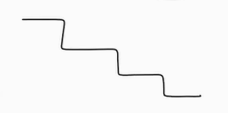

**Imp Points below**

1. Predictions of decision trees are neither smooth nor continuous, but piecewise constant

approximations as seen in the above figure. Therefore, they are not good at

extrapolation.

Hum Decision Trees bss vahi data pe lagate hai jaha hume pata hota hai ki Inputs jo hai vo restricted hai Example marks : iska range bss 0 to 100 tak hie hai

E.g jaha nahi lagaskte hum that is Profit : Profit ka range kitna bhi hoskta hai

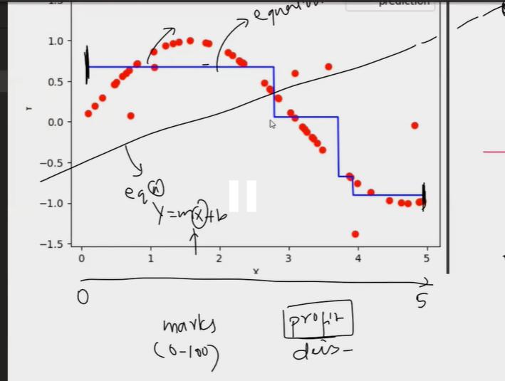

**This limitation is inherent to the structure of decision tree models. They are very useful**

**for interpretability and for handling non-linear relationships within the range of the**

**training data,** but they aren't designed for extrapolation. If extrapolation is important for

your task, you might need to consider other types of models.